|  |  |  |
| --- | --- | --- |
| **CYCLE REPORT 3** | Project Name | Project Manager |
| **Burgeen Entrepreneur and Crowd-funding System** |  |
| **Client** | **Athena Wang**  Co-founder of Burgeen.com | |
| **Team Members** | **MingQian Li**  **YiRan Pan**  **Tyrza Adelia Winata** | |

# Red Flags from this cycle

Due to the last cycle, the red flag is targeted to finish whole project and documentation as well. Eventually, the preparation of delivery should be on the processing.

# Previous Cycle Results

|  |  |
| --- | --- |
| Item | statement |
| Modules insertion for home page | Compromise and completed |
| Set up for the crowd funding invest port | Completed |
| Implement of the current outfit design | Completed |
| Try to enable the multi-website function. | Completed |
| Try to emphasize the brand image of Burgeen | Completed |
| Complete the content of the interface with consistent design style | Completed |
| Create icons and artworks needed for the interface | Completed |
| Decision for appropriate agile methodology | Scrum be chosen |
| Set up for entrepreneur platform | Completed |
| Promote the platform and try to attract more students to register and test | Just a few, on the process |

# Customer Feedback

The conclusion of customer feedback:

|  |  |  |
| --- | --- | --- |
| Item | Feedback | solution |
| Design | Quite good, but need more adjustment of fonts and slider pictures | Re-adjust on processing |
| Function | Prefect, the information and crowd funding system can work properly, the users also can have their own sites | Gratitude |
| User experience | The experience is quite good, people can search information, scan the information and create their own project easily, frequently | Continue to test and maintain |
| Operation | The operation for users is balanced well, users can get the expected information in seconds | Continue to test and maintain |
| Further features | It is better to have mobile app for the platform | Plan in ICT2 |

# Cycle Plan (Use 2 level WBS)

1. **Project Management**

*Responsible: Charles, Li MingQian*

* 1. Project Schedule
* Set the schedule and due dates of every project phases
  1. Requirements document
* Negotiates client requirements
* List clear statements description from client as to what they wanted
  1. Entrepreneur platform set up
* Promote the student to register and test
* Explore and improve the performance from original burgeen
  1. Weekly client’s feedback
* Record every feedback given from the client
  1. Meeting agendas and duration
* Record an activity documentation for every meeting with client and its duration
* Meet with the supervisor regularly

1. **Technical Design**

*Responsible: Vizor, Pan YiRen*

* 1. Implement of crowd funding platform
* Project set up flow
* Configuration of the invest port
* Build up the major ways of payment for invest port.
  1. Modules modification in home page
* Implement of modules insertion according to client’s needs
* Other adjustments of the details.

1. **Implementation**

*Responsible: Tyrza Adelia Winata*

* 1. Adjust design following to the client’s demand
  2. Assist to check the points of project
  3. Testing
* Page test checklist
* User test checklist

**Top Requirements (Features)**

1. User agreement to delivery
2. Public testing
3. Plan to ICT2

# Supporting Documents:

## Gantter

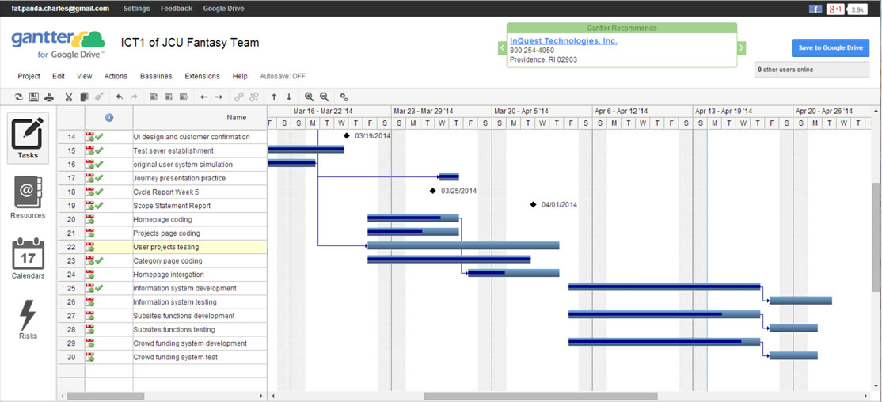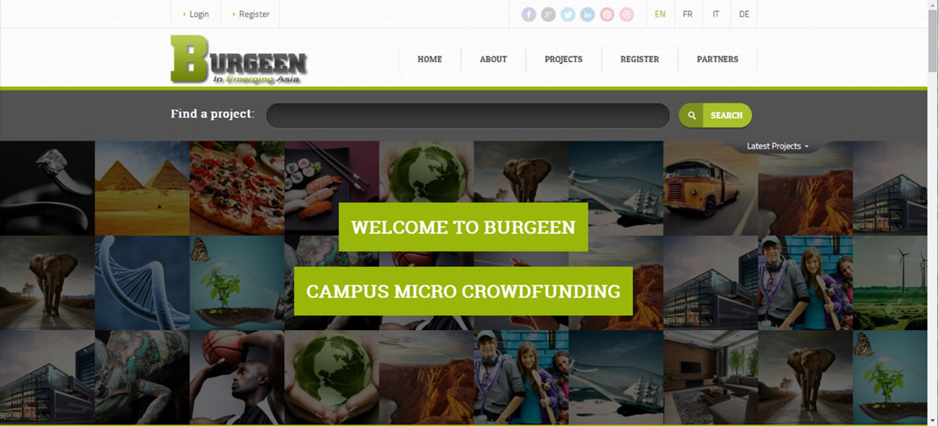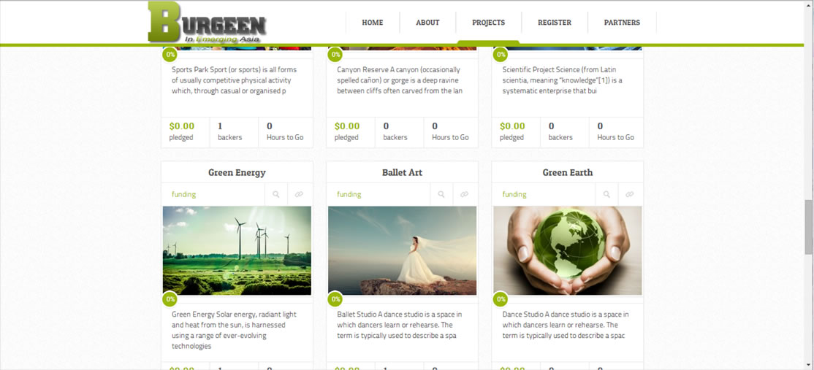

Below is the result of a performance test of the website performed using the online tool: http://www.webpagetest.org/

